Looking for that perfect gift to give this year? Why not give the give of Watch Folder?! I just updated it to work with Vault 2012, and I added in support for HTML style emails.
In case you aren't familiar with it, Watch Folder is an app that allows you to "watch" a set of Vault folders so that you receive email notifications when files get added or updated in those folders.
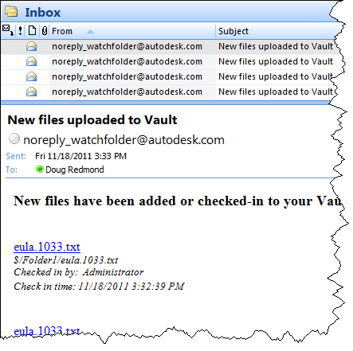

Requirements:
- Vault Workgroup/Collaboration/Professional 2012
- Job Server enabled
- An SMTP server somewhere on the network
NOTE: This isn't something you can just download and run. The Vault administrator needs to set up some server components before this feature can be used.
Click here to download the application
Click here to download the source code

To use
For Vault users, download the application and run the installer. Just make sure that the administrator has set up the Vault environment first. Next you just right-click on a folder that you want to watch. Select the Watch Folder command and decide how frequently you want notifications.
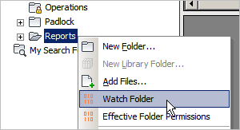
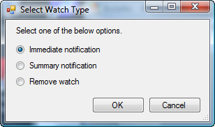

For Vault administrators, the application and run the installer. Next follow the instructions in the readme file in the install folder (%ProgramData%\Autodesk\Vault 2012\Extensions\WatchFolderCommand).
Notes:
- A watch on a folder will automatically apply to any sub-folders.
- Removing a watch will also remove watches on sub-folders.
- You can't have an immediate watch and a summary watch on the same folder. Setting a folder to one type overwrites the existing setting.
- You need to be at least Document Editor (level 1) in order to set up a watch on a folder.
- You need to have a valid email address in your Vault user settings.
- The contents of the email can be customized by the Vault administrator. See readme file.
As with all the samples on this site, the legal disclaimer applies.

